**Employee dataset Analysis**

**About the Dataset**

This dataset contains information about employees in a company, including their educational backgrounds, work history, demographics, and employment-related factors. It has been anoymized to protect privacy while still providing valuable insights into the workforce.

**Columns:**

**Education:** The educational qualifications of employees, including degree, institution, and field of study. Joining Year: The year each employee joined the company, indicating their length of service.

**City**: The location or city where each employee is based or works. Payment Tier: Categorization of employees into different salary tiers.

**Age**: The age of each employee, providing demographic insights. Gender: Gender identity of employees, promoting diversity analysis. Ever Benched: Indicates if an employee has ever been temporarily without assigned work. Experience in Current Domain: The number of years of experience employees have in their current field.

**Usage:**

This dataset can be used for various HR and workforce-related analyses, including employee retention, salary structure assessments, diversity and inclusion studies, and leave pattern analyses. Researchers, analysts, and HR professionals can gain valuable insights from this dataset.

**Potential Research Questions:**

What is the distribution of educational qualifications among employees?

How does the length of service (Joining Year) vary across different cities?

Is there a correlation between Payment Tier and Experience in Current Domain?

What is the gender distribution within the workforce?

**Acknowledgments:**

We would like to acknowledge the contributions of our HR department in providing this dataset for research and analysis purposes.

1. What is the distribution of educational qualifications among employees?

|  |  |  |
| --- | --- | --- |
| **Statistics** | | |
| Education of the employee | | |
| N | Valid | 4653 |
| Missing | 0 |

|  |  |  |  |  |  |
| --- | --- | --- | --- | --- | --- |
| **Education of the employee** | | | | | |
|  | | Frequency | Percent | Valid Percent | Cumulative Percent |
| Valid | Bachelors | 3601 | 77.4 | 77.4 | 77.4 |
| Masters | 873 | 18.8 | 18.8 | 96.2 |
| PHD | 179 | 3.8 | 3.8 | 100.0 |
| Total | 4653 | 100.0 | 100.0 |  |

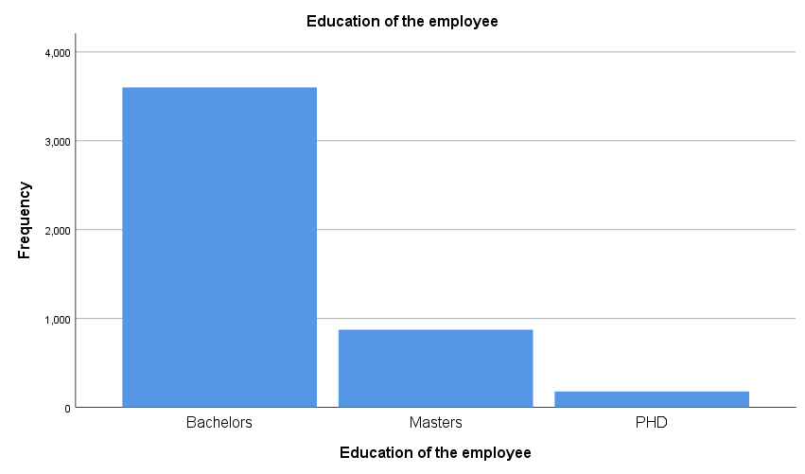

**Note:** From the above,there are more employees with Bachelors than employees with masters and PHD**.**

2. How does the length of service (Joining Year) vary across different cities?

|  |  |  |  |  |  |  |
| --- | --- | --- | --- | --- | --- | --- |
| **Case Processing Summary** | | | | | | |
|  | Cases | | | | | |
| Valid | | Missing | | Total | |
| N | Percent | N | Percent | N | Percent |
| Year of Employment * City of Residence | 4653 | 100.0% | 0 | 0.0% | 4653 | 100.0% |

|  |  |  |  |  |  |
| --- | --- | --- | --- | --- | --- |
| **Year of Employment * City of Residence Crosstabulation** | | | | | |
| Count | | | | | |
|  | | City of Residence | | | Total |
| Bangalore | New Delhi | Pune |
| Year of Employment | 2012 | 302 | 92 | 110 | 504 |
| 2013 | 340 | 149 | 180 | 669 |
| 2014 | 387 | 126 | 186 | 699 |
| 2015 | 314 | 134 | 333 | 781 |
| 2016 | 313 | 95 | 117 | 525 |
| 2017 | 369 | 474 | 265 | 1108 |
| 2018 | 203 | 87 | 77 | 367 |
| Total | | 2228 | 1157 | 1268 | 4653 |

NOTE:

From the result above, 2012 witnesses a great start in Bangalore, but dwindles across other cities .

In 2017, there was really a massive employment even though 2014 recorded a more higher number of employees, the number increases in New Delhi making it the year with the highest number of employees in New Delhi but dwindles in Pune. 2017 recorded the highest number of employees.

2018 recorded the lowest number of employees across all the Cities.

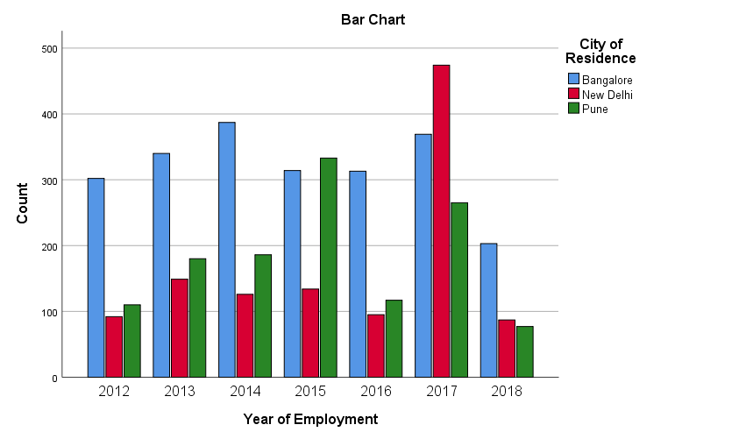

3. Is there a correlation between Payment Tier and Experience in Current Domain?

**Correlations**

|  |  |  |  |
| --- | --- | --- | --- |
| **Correlations** | | | |
|  | | Experience of employees | Payment Level |
| Experience of employees | Pearson Correlation | 1 | .018 |
| Sig. (2-tailed) |  | .212 |
| N | 4653 | 4653 |
| Payment Level | Pearson Correlation | .018 | 1 |
| Sig. (2-tailed) | .212 |  |
| N | 4653 | 4653 |

NOTE:

There is a positive relationship between Experience og employees and payment level.

The p_value (0.212) shows that there is a week correlation amongst these variables and so there is only a 21.2% chance of occurrence.

The result is not statistically significant.

4. What is the gender distribution within the workforce?

|  |  |  |  |  |  |
| --- | --- | --- | --- | --- | --- |
| **Sex of employee** | | | | | |
|  | | Frequency | Percent | Valid Percent | Cumulative Percent |
| Valid | Female | 1875 | 40.3 | 40.3 | 40.3 |
| Male | 2778 | 59.7 | 59.7 | 100.0 |
| Total | 4653 | 100.0 | 100.0 |  |

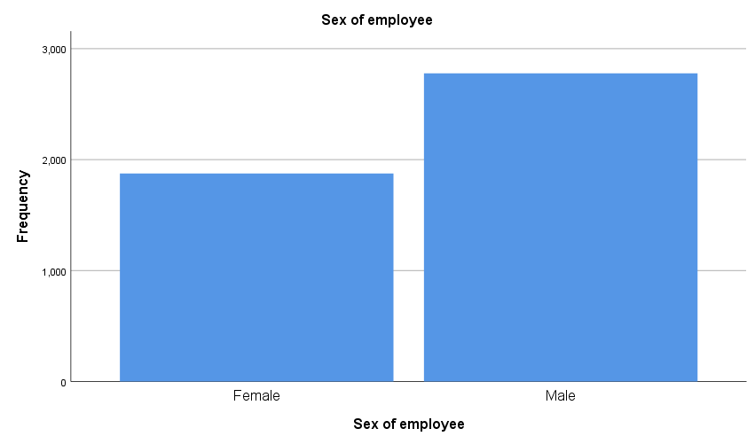

NOTE:

There are more male employees than female employees.

|  |  |  |  |
| --- | --- | --- | --- |
| **Correlations** | | | |
|  | | Experience of employees | Age of employee |
| Experience of employees | Pearson Correlation | 1 | -.135** |
| Sig. (2-tailed) |  | .000 |
| N | 4653 | 4653 |
| Age of employee | Pearson Correlation | -.135** | 1 |
| Sig. (2-tailed) | .000 |  |
| N | 4653 | 4653 |

|  |
| --- |
| **. Correlation is significant at the 0.01 level (2-tailed). |

NOTE: The p_value .000 indicate a high statistical significance.

This means that the experience of employees does not in any way have anything to do with the employee’s age.

**Conclusion**

The analysis of the employee dataset reveal key insights into employee Education, JoiningYear, City, PaymentTier, Age, Gender, Everbenched, leaveOrNot and Experience. Specifically, the study examine (Education, City, JoiningYear, PaymentTier, Gender, LeaveOrNot and Experience). The Findings suggest(

* For Education; There are more employees with Bachelors than both Masters and PHD.
* For JoiningYear; There were more people employed in the year 2017 while the year 2018 recorded the least number of employment.
* For Gender within the workforce; The findings revealed that there are more males within the workforce than females.
* For LeaveOrNot; There are more number of employees who are on leave than the number of employees who are not on leave. This was later broken down according to educational qualifications which reavealed that more number of employees with Bachelors did not have leave. The large number is due to the fact that the employees with bachelors constitute the highest number of employees within the workforce.
* For Experience; The Findings revealed correlation between experience and paymentTier, indicating a low positive correlation between the two. ).
* Although there are still numerous insights which can be obtained from this dataset, the findings were limited to the above.

**Reccommendations**

From the Analysis above, the following recommendations were made:

**Improve Employee Retention:**

The company or organization should focus more on initiative that enhance jobs satisfaction and engagement. This should be made particularly for employees with a good reputation.

**Training and development:**

The company should invest in targeted training programs to address skill gaps and enhance productivity.

**Performance Management:**

The company should refine performance evaluation process to ensure fairness, transparency and alignment to the company's standards in other to boost unity and productivity.